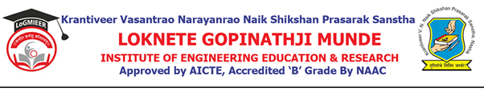
AD-301 | Activity Report  on Expert Lecture | Academic Year: 2025-26
Rev-00 | Activity Report  on Expert Lecture | Semester: I
DEPARTMENT OF CIVIL.ENGINEERING
Particulars | Description
Activity | Expert Lecture
Activity level | Departmental
Title | Expert Lecture on “Control of Air Pollution".
Speaker / Resource Person Name Designation  Organization/Institute Name and address | Dr. Mahesh R. Gadekar,  Assistant Professor,  Shri Guru Gobind Singhji Institute of Engineering and Technology (SGGSIET), Nanded
Organized by | Civil Engineering Department
Venue | Class Room No. 109, Department of Civil Engineering
Date & Time | 06th October 2025, 11.30 am to 01:30 pm
Objectives of the activity | 1. To familiarize students with the sources and impacts of air pollution.  2. To introduce various air pollution control devices and their working principles.  3. To explain emission standards and regulatory requirements for pollution control.  5. To promote awareness of sustainable and eco-friendly practices for air quality management.
Outcomes of activity | 1. Understand the major sources and effects of air pollution.  2. Explain different air pollution control devices such as cyclones, filters, scrubbers, and electrostatic precipitators.  3. Interpret emission standards and regulatory frameworks related to air quality.  4. Develop awareness about sustainable and eco-friendly pollution control practices.
Targeted participants | BE Civil Engineering Students
Targeted participants | 28
Total no. of participants, | 16
Participation Percentage | 57%
Content of the activity | Introduction to air pollution, sources, and effects.  Air pollution control methods and equipment (cyclones, filters, scrubbers, ESP),Emission standards and monitoring techniques,Recent advances and sustainable practices in pollution control
Relevance to POs | PO2 (Problem Analysis): Developed analytical ability to identify and propose suitable control methods for air quality problems.  PO5 (Modern Tool Usage): Understood modern tools and technologies used for monitoring and controlling air pollution.  PO7 (Environment and Sustainability): Strengthened the understanding of sustainable development and eco-friendly practices in civil engineering.  PO10 (Communication): Improved technical communication through interaction and discussion during the expert lecture
Relevance to PSOs | PSO1: The session helped students understand complex environmental problems and modern technological approaches used in air pollution control systems.  PSO2: It enhanced students’ awareness of professional civil engineering practices with due consideration to environmental and societal impacts.
Methodology used | Expert lecture through presentation and visual aids  Interactive discussion on real-life air pollution control case studies
Brief Description of the Activity | An expert lecture on “Control of Air Pollution” was conducted for Fourth Year Civil Engineering students under the subject Air Pollution and Control. The session aimed to enhance students’ understanding of various air pollution control methods, equipment, and regulatory standards. The expert explained practical applications of pollution control devices such as cyclones, scrubbers, filters, and electrostatic precipitators, supported by case studies and real-world examples. The lecture provided valuable insights into sustainable and modern approaches for maintaining air quality and emphasized the role of civil engineers in environmental protection.
Geo- tag photos of the Activity | 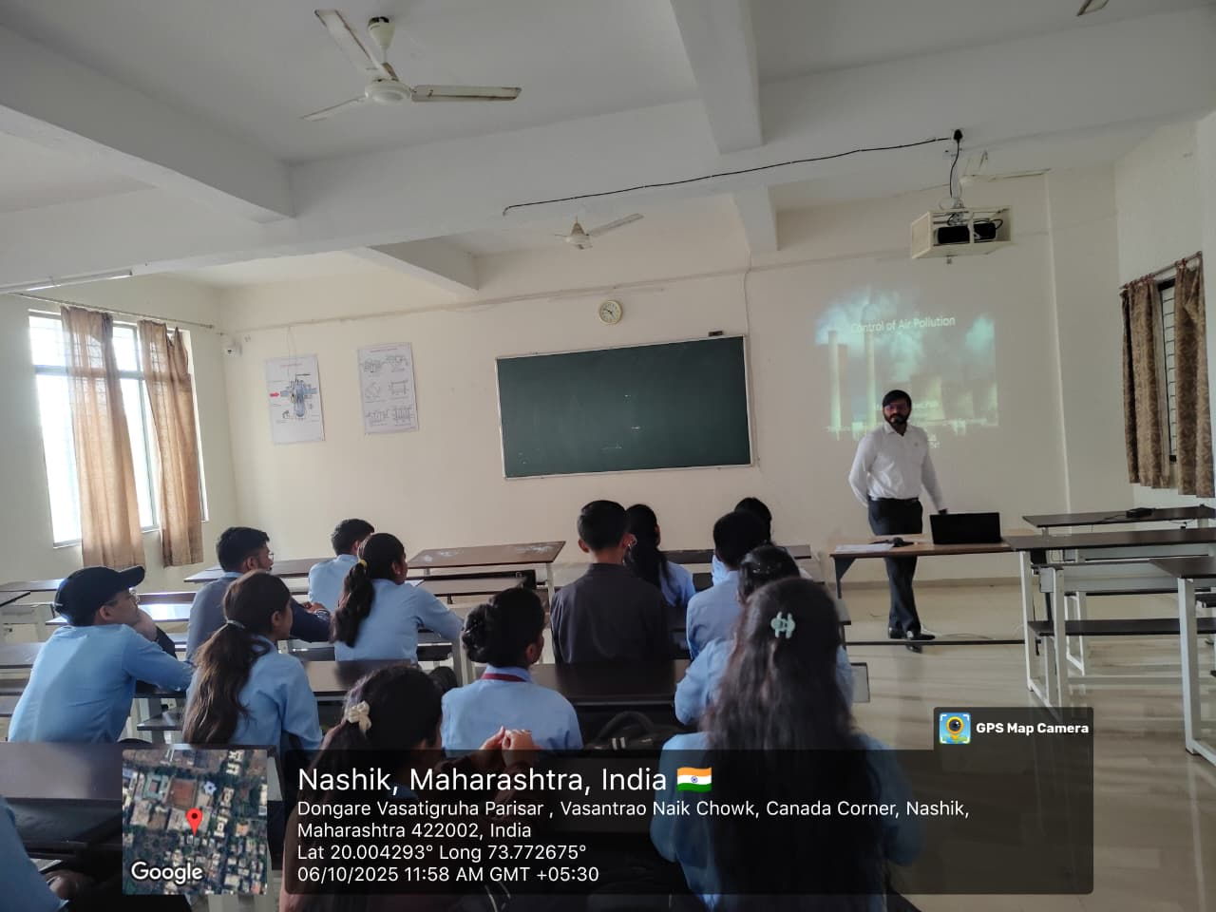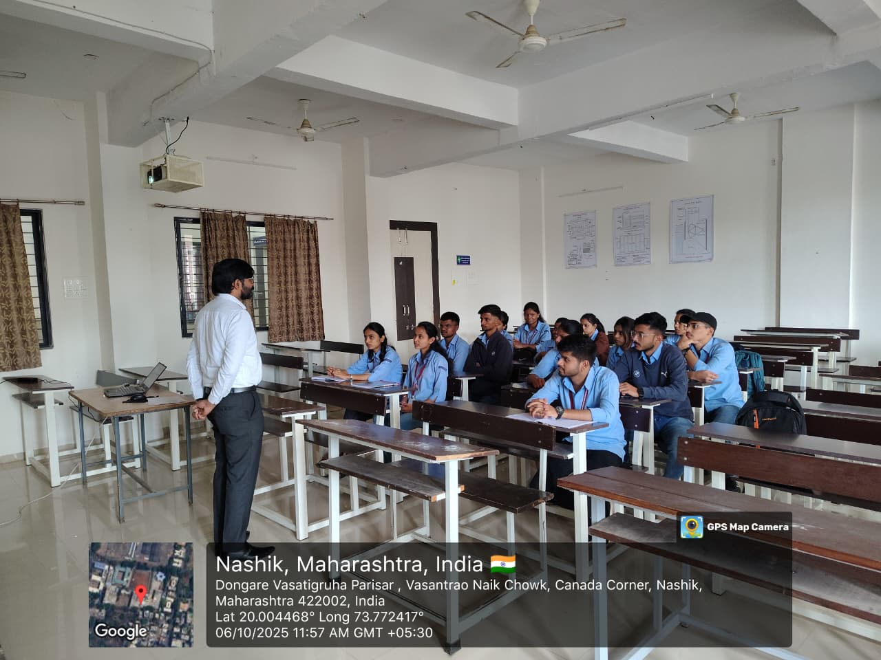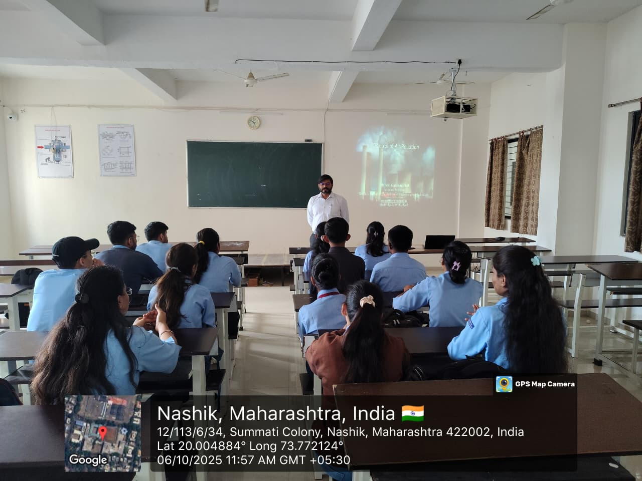

A. V. Boraste | Dr. S. R. Baviskar | Prof. S.S. Punde | Prof. N.V. Kapade
CESA Co-ordinator | HOD, Civil | Dean, Academics | IQAC, Co-Ordinator

