
AD-301 | Activity Report  on Expert Lecture | Academic Year: 2025-26
Rev-00 | Activity Report  on Expert Lecture | Semester: I
DEPARTMENT OF CIVIL.ENGINEERING
Particulars | Description
Activity | Expert Lecture
Activity level | Departmental
Title | Expert Lecture on “Preparation Strategies for Competitive Exams".
Resource Person Name Designation  Organization Name and address | Er.Pravin Daitkar  Assistant Engineer,PWD,  Shree Ganesh Academy,  Ashok Stambh, Nashik
Organized by | Civil Engineering Department
Venue | Seminar hall room no.123
Date & Time | 8th October 2025, 11.30 am to 01:30 pm
Objectives of the activity | - To guide students about various competitive examinations related to civil engineering and general aptitude.  - To familiarize students with examination patterns, preparation techniques, and time management strategies.  - To motivate students to plan their studies systematically for GATE, MPSC, UPSC, and other competitive exams.  - To create awareness among students regarding career opportunities through competitive exams.
Outcomes of activity | - Students gained insights into the structure and syllabus of various competitive exams.  - Participants understood effective preparation techniques, including study planning and revision methods.  - Students became aware of the importance of consistent practice and analytical thinking.  - The session enhanced students’ confidence and motivated them to begin focused preparation for their target exams.
Targeted participants | SE,TE, BE Civil Engineering Students
Targeted participants | 124
Total no. of participants, | 70
Participation Percentage | 56%
Content of the activity | • Overview of national and state-level competitive exams (GATE, MPSC, etc.)  • Discussion on syllabus, exam patterns, and weightage analysis.  • Importance of aptitude, reasoning, and technical knowledge in exams.  • Motivational insights and real-life experiences shared by the expert.
Relevance to POs | • PO2: Problem analysis – Students learned to analyze and approach problems systematically during exam preparation.  • PO8: Individual and teamwork – Encouraged collaborative learning and group preparation for exams.  • PO09: Communication skills – Enhanced students’ confidence in presenting ideas and answers effectively.  • PO11: Life-long learning – Emphasized continuous learning as essential for success in competitive exams and professional growth.
Relevance to PSOs | • PSO1: Application of technical knowledge to solve civil engineering problems relevant to competitive exams.  • PSO3: Application of design, analysis, and operational concepts through exam-oriented learning.
Methodology used | Expert lecture through presentation and visual aids  Interactive discussion on Preparation for Competitive Exams
Brief Description of the Activity | An Expert Lecture on “Preparation Strategies for Competitive Exams” was organized on 8th October 2025 for Civil Engineering students. The resource person provided detailed guidance on the preparation methodology for exams like GATE, MPSC,etc.. The session included insights into syllabus analysis, resource planning, and time management. Students actively participated and interacted with the speaker, gaining valuable tips and motivation to pursue their exam goals. The session concluded with a Q&A and feedback from students appreciating the informative and inspiring talk.
Geo- tag photos of the Activity | 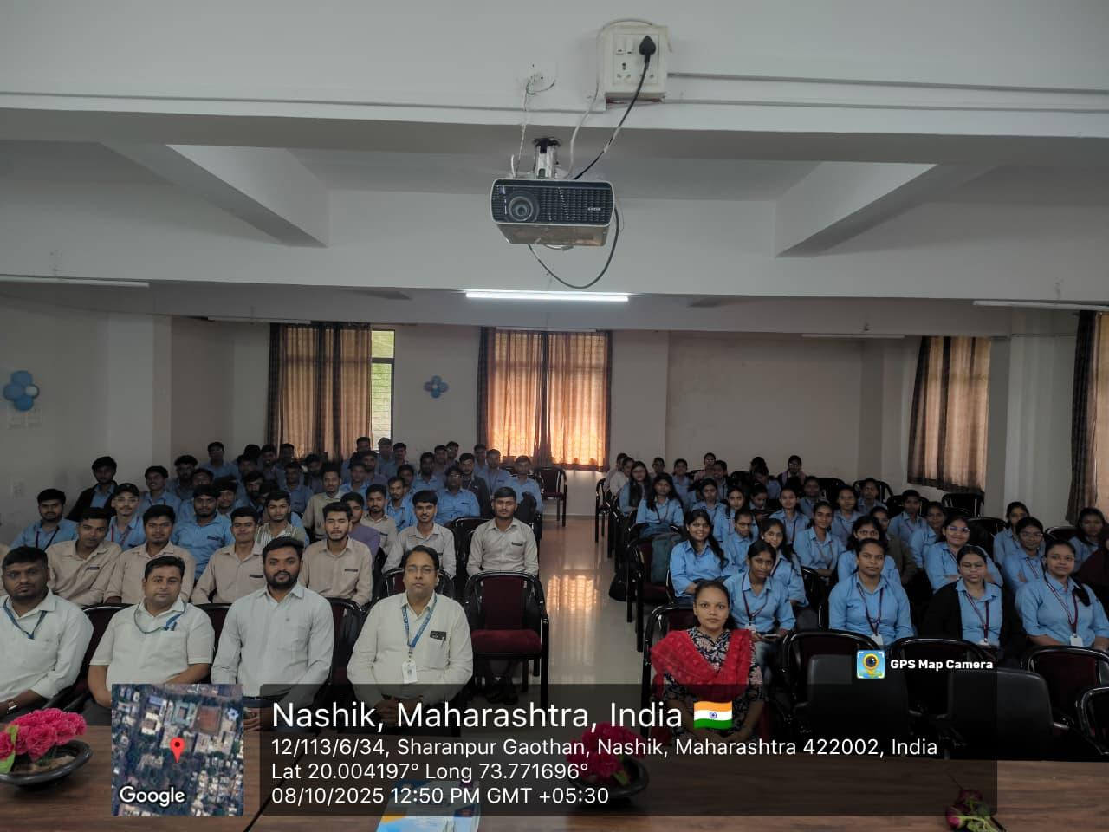  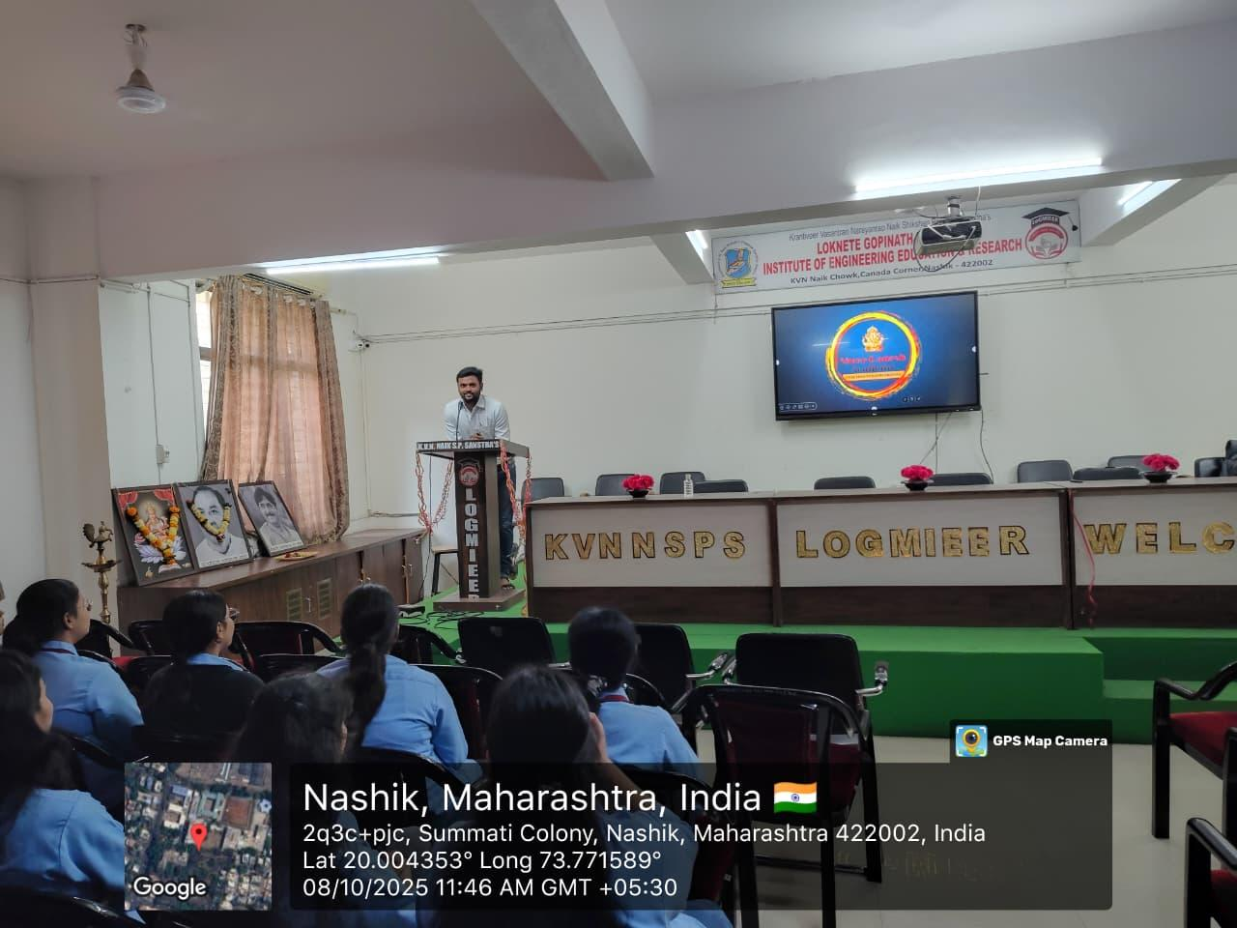  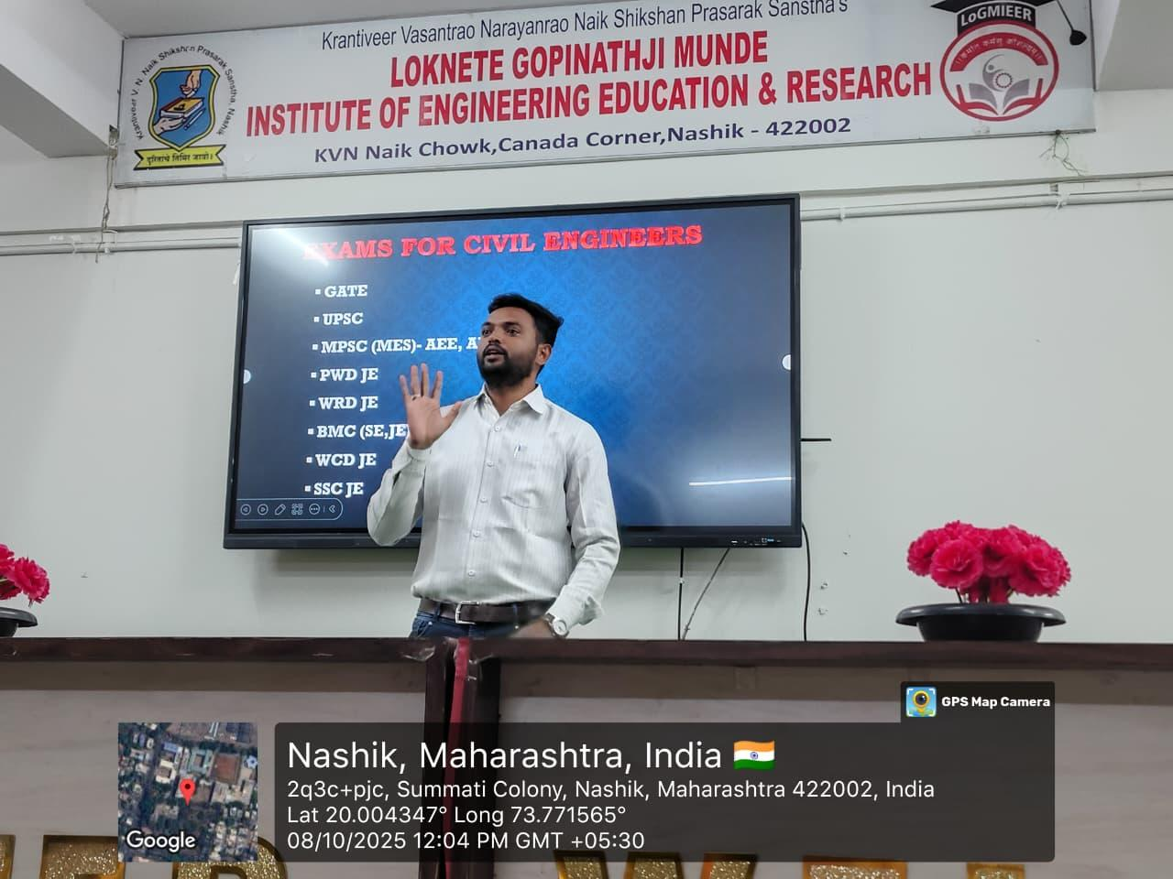
Prof. S.S.Bodke | Activity Co-ordinator
Prof. M. R. Gupta | Drive Co-ordinator
A. V. Boraste | Social media Co-ordinator
Dr. S. R. Baviskar | HOD, Civil
Prof. D.B.Pawase | Training & Placement Officer
Prof. N.V. Kapade | IQAC, Co-Ordinator

