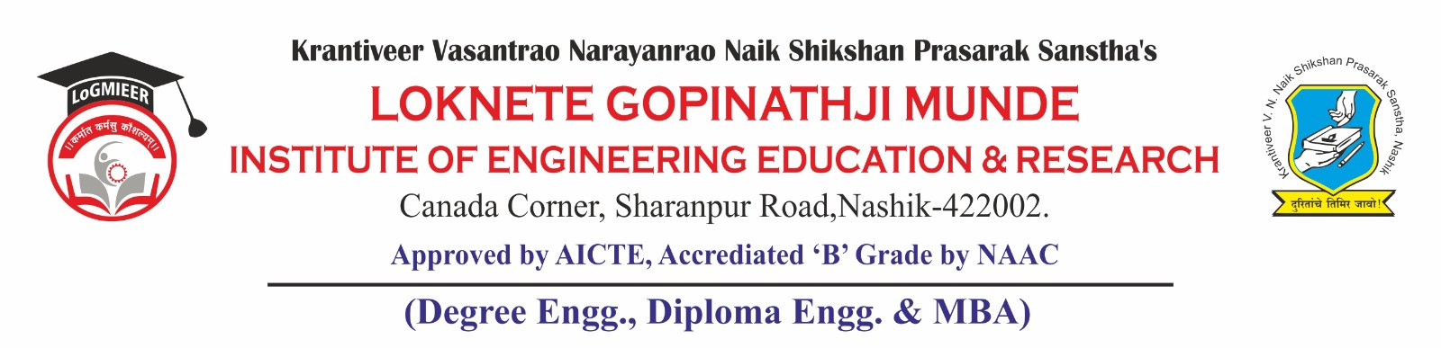
AD-301 | Activity Report  Survey Workshop | Academic Year: 2025-26
Rev-00 | Activity Report  Survey Workshop | Semester: I
DEPARTMENT OF CIVIL. ENGINEERING
Particulars | Description
Activity | Workshop
Activity level | Departmental
Title | Hands-on Training on DGPS & Total Station
Speaker / Resource Person Organization | Er. Saurabh Raut  Adarsh Land Survey, Nashik
Organized by | Department of Civil Engineering
Venue | Tutorial Classroom & Field Survey Site at Tomato Market, Girnare
Date & Time | 7th October 2025 to 9th October 2025
Objectives of the activity | - To provide practical exposure to modern surveying instruments — DGPS and Total Station.  - To enhance field measurement, data collection, and coordinate computation skills.  - To bridge the gap between theoretical concepts and real-world surveying applications.
Outcomes of activity | - Students learned setup, and operation of DGPS and Total Station.  - Developed skills in data collection, mapping, and accuracy evaluation.  - Strengthened understanding of field survey project execution.
Targeted participants | SE Civil Engineering Students
Total no. of participants | 40
Content of the activity | Introduction to DGPS and Total Station, instrument setup, calibration, data acquisition, field survey at Girnare, data processing, and preparation of topographic maps.
Relevance to POs | PO2: Problem Analysis  PO6: The Engineer and The World  PO9: Communication  PO5: Engineering Tool Usage  PO11: Life-Long Learning
Relevance to PSOs | PSO2: Proficiency in Modern Tools and Techniques  PSO3: Problem Solving and Project Execution Skills
Methodology used | Live demonstration, hands-on field practice, instrument handling, data analysis, and interactive discussions.
Brief Description of the Activity | The Department of Civil Engineering organized a three-day workshop on DGPS and Total Station from 7th to 9th October 2025 under CESA. The sessions were conducted daily from 10:00 AM to 4:45 PM. Faculty members guided SE Civil students through the operation, calibration, and data collection using modern surveying instruments. Students also performed a field survey at Tomato Market, Girnare, to collect real-time data and generate maps. The workshop provided valuable insights into advanced surveying techniques, enhancing students’ practical understanding and technical competence.
Geo- tag photos of the Activity | 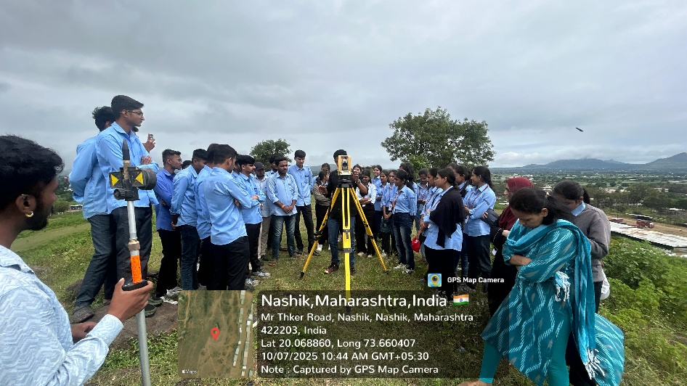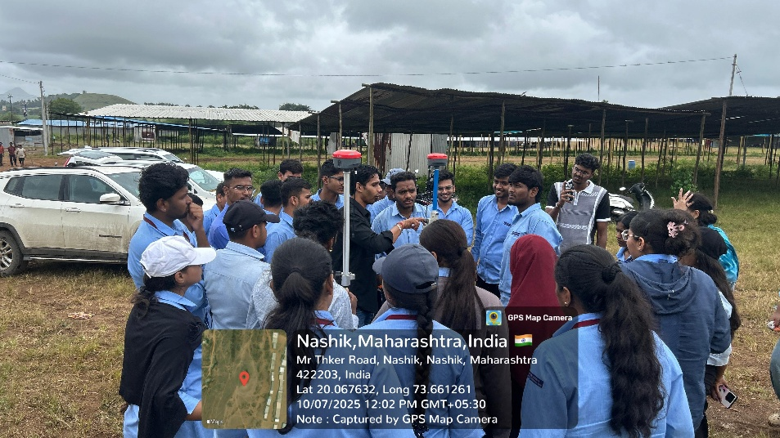

A. V. Boraste | Dr. S. R. Baviskar | Prof. S.S. Punde | Prof. N.V. Kapade
Workshop Co-ordinator | HOD, Civil | Dean, Academics | IQAC, Co-Ordinator

